Alachua County
Recovery Plan

American Rescue Plan

State and Local Fiscal Recovery Funds

Alachua County Citizens Vaccination Incentive Program

Executive Summary
In response to the COVID-19 Pandemic, the Federal government has provided Alachua County funding through the American Rescue Plan – State and Local Fiscal Recovery Funds. One Category of response is Public Health – COVID-19 Vaccinations (1.1). Alachua County is currently considered a “hotspot” of transmission. As of the week of August 13th, the County has reported 30,824 cumulative cases, and is at a 14.8% positive test rate. Vaccination rates in Alachua County are at ~63% which reflects ~151,000 vaccinated citizens out of ~240,000 eligible (12 years old and over) population. (see Weekly Data Table below). The spread of the Delta variant has resulted in increased demand for hospital emergency rooms and admission, including pediatric admissions. Data indicates the vast majority of cases resulting in hospitalization are from people not vaccinated (see Hospital Information table on the next page).

The President of the United State and CDC emphasize the importance of reaching a level of at least 80% of all people need to be vaccinated. Since children under 12 are currently not eligible for the vaccine, we need to reach as close to 100% of eligible citizens to become vaccinated. Through the latest wave of the Delta variant many resistant to the vaccines are starting to reconsider and further analyze the data and impact of the unvaccinated getting COVID-19. Incentives are a way to possibly convince those reconsidering, unsure, or undecided to get vaccinated. The most efficient effective rapid method to deliver this program is through partnerships with the pharmacies that currently provide vaccines and the Department of Health. These providers already have logs of those receiving shots and can easily provide them a gift card and then a log to the County weekly for reimbursement.

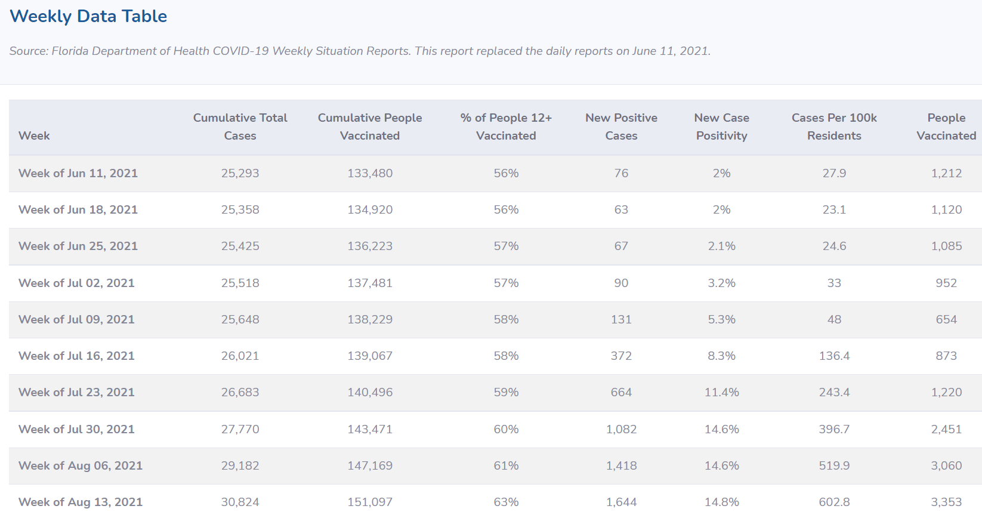

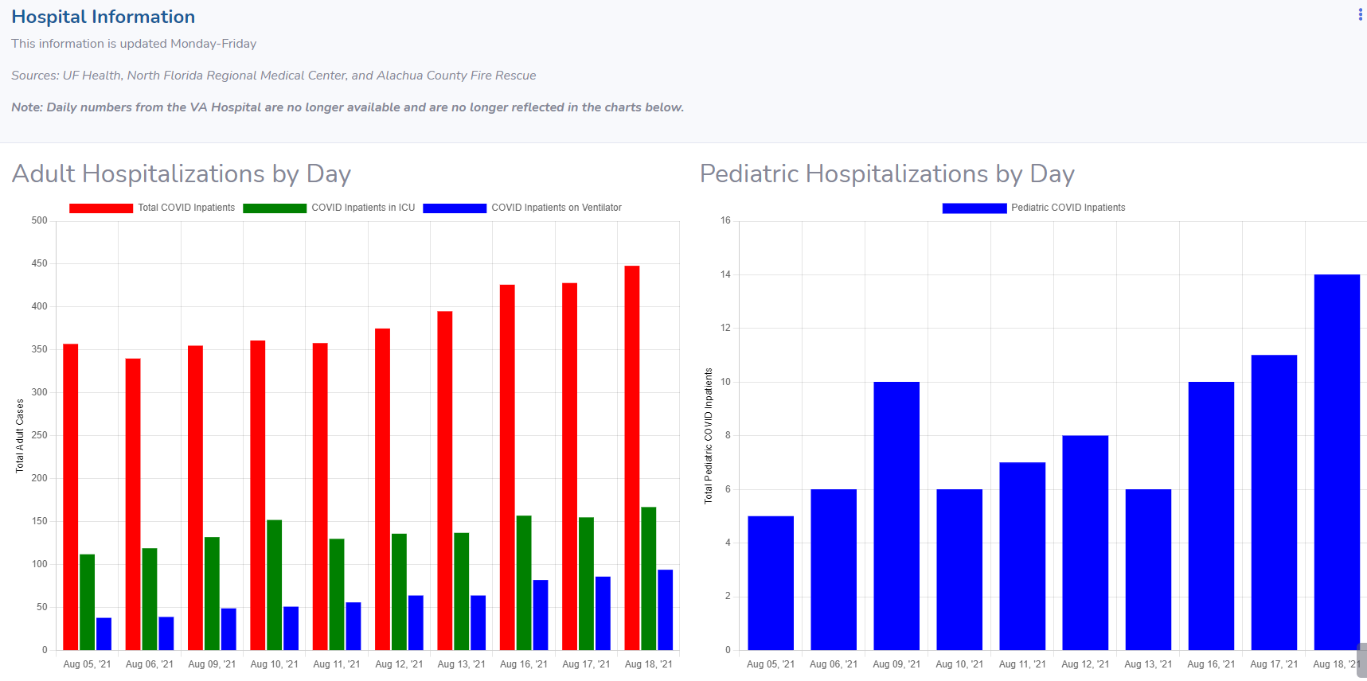

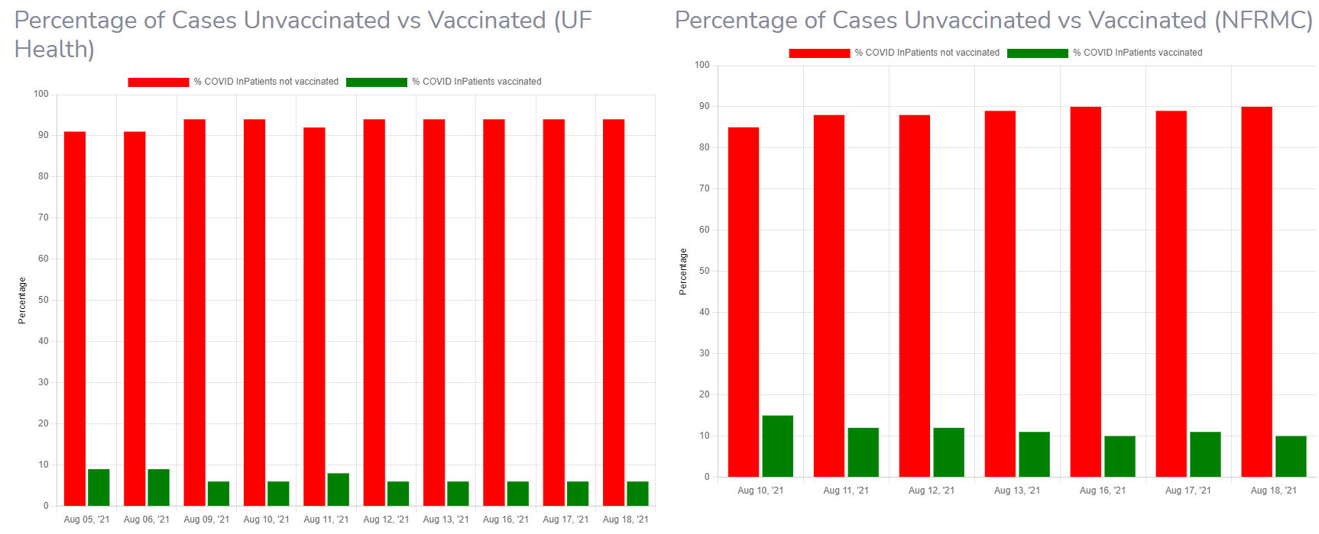

Uses of Funds
The Alachua County Citizen Vaccination Program aligns with the Public Health, COVID-19 Vaccination category (1.1) under the American Rescue Plan – State and Local Fiscal Recovery Funds. Having a fully vaccinated population is paramount to ending COVID-19 in our society.

Under the Alachua County Citizen Vaccination Program, all Alachua County residents will be provided an incentive award of $25 for each COVID-19 vaccination regardless of manufacturer, including booster shots.

The program maximum cost will be $4,500,000, which represents a 100% vaccination rate. The realistic goal is to get 45,000 additional citizens fully vaccinated representing 81% of the eligible population, and will cost $2,250,000.

Goals and Measures
The vaccination program will run from September 1 to September 30, 2021. The County will attempt to partner with vaccine providers, CVS, Hitchcock’s, Publix, Walgreen’s, Walmart, Wise’s, Winn-Dixie and the Public Health Department to supply gift cards at the time of vaccination. The providers will provide list, without identifiable information, of how many vaccines were administered for reimbursement.
Update September 28, 2021 – The County was able to partner with Abel’s Pharmacy, CVS, Hitchcock’s, West-end Pharmacy, Wise’s Pharmacy, and Winn-Dixie.

Our goal is to attain an 80% vaccination rate of the eligible public in Alachua County. We will measure and report progress to the Manager on a weekly basis and provide a final report of effectiveness of the program in October 2021.
Update September 28, 2021 – Due to the County-wide eligible citizen fully vaccinated rate remaining less than 70%, the program has been extended until October 31, 2021.

