Alachua County
Recovery Plan

American Rescue Plan

State and Local Fiscal Recovery Funds

County Government Health Plan Vaccination Program
ARP2021x003

GENERAL OVERVIEW

Executive Summary
In response to the COVID-19 Pandemic, the Federal government has provided Alachua County funding through the American Rescue Plan – State and Local Fiscal Recovery Funds. One Category of response is Public Health – COVID-19 Vaccinations (1.1). Alachua County is currently considered a “hotspot” of transmission. As of the week of August 13th, the County has reported 30,824 cumulative cases, and is at a 14.8% positive test rate. Vaccination rates in Alachua County are at ~63% which reflects ~151,000 vaccinated citizens out of ~240,000 eligible (12 years old and over) population. (see Weekly Data Table below). The spread of the Delta variant has resulted in increased demand for hospital emergency rooms and admission, including pediatric admissions. Data indicates the vast majority of cases resulting in hospitalization are from people not vaccinated (see Hospital Information table on the next page).

Alachua County Government, including Constitutional Officers, provide health insurance benefits to employees and their families. This insurance is funded through premiums paid by employees as well as the Government itself. Health insurance cost in response to COVID-19 from January 1, 2020 to June 30, 2021 was $3,578,077. As a self-funded plan, these cost drive up premiums, causing the County to divert funds for public services to the health plan. In that vaccinated plan members will dramatically reduce the need for hospitalization in the future, cost can be better contained and left in funds to deliver public services. Our goal is to have as many vaccinated health plan members as possible to reduce hospitalizations and prevent the spread of COVID-19.

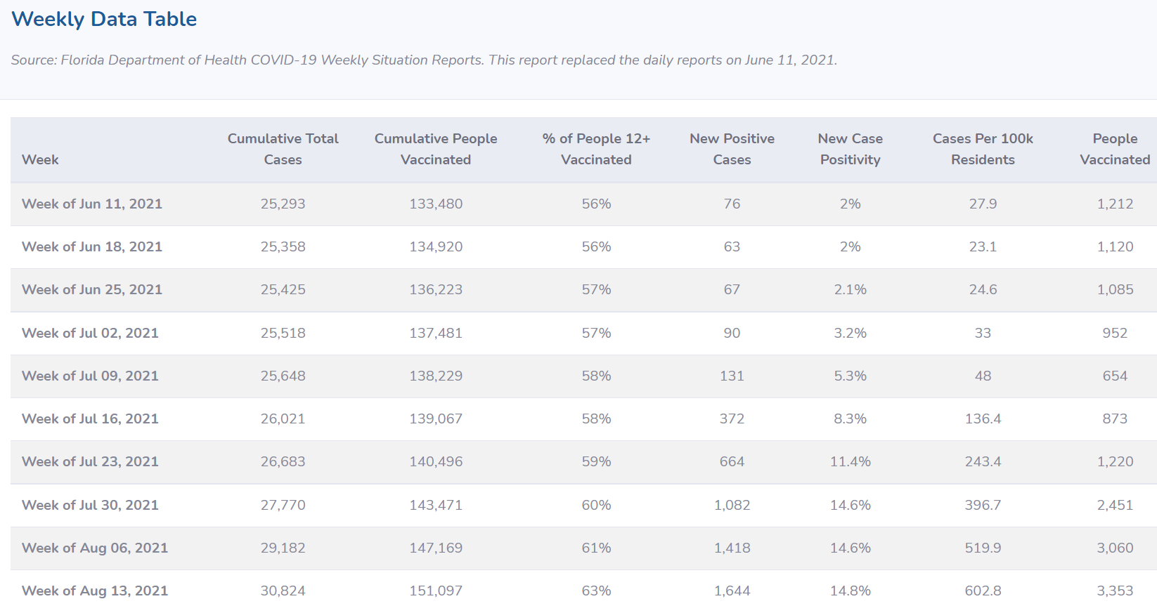

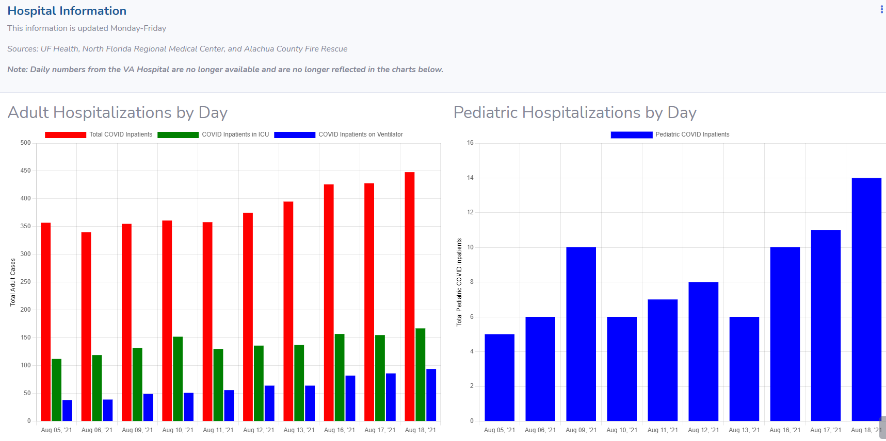

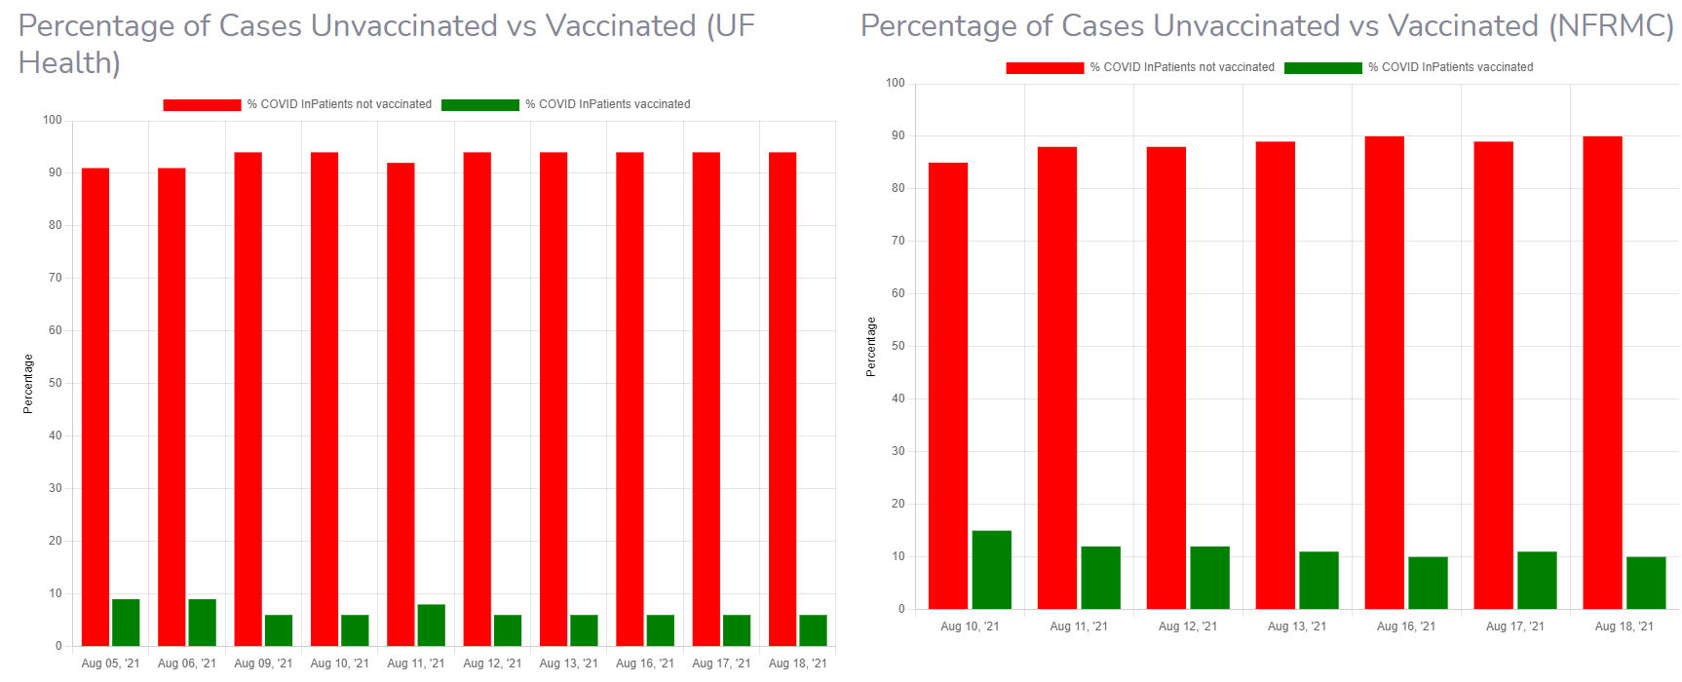

Uses of Funds
The Alachua County Government Health Plan Vaccination Program aligns with the Public Health, COVID-19 Vaccination category (1.1) under the American Rescue Plan – State and Local Fiscal Recovery Funds. Reducing hospitalizations and the associated cost for plan members will limit future premium increases and allow funds to remain available to provide services to the public.

Under the Alachua County Government Employee Health Plan Program, all members of the Alachua County Health Insurance Plan will be provided an incentive award of $10 per member per month premium credit upon being fully vaccinated. If they are not fully vaccinated prior to October 1, 2021, they may receive a prorated credit for the remainder of the fiscal year upon being fully vaccinated.

County staff will coordinate with the Clerk’s office to ensure eligibility with the American Rescue Plan, and for any reason it is determined to be ineligible the County will use the General Fund dollars set aside for COVID-19 relief.

The program maximum cost will be $450,000. This would represent a 100% eligible member vaccination rate. The credit will be a maximum of $50 per month per contract (5 per family for credit) and the credit is limited to the amount they pay as a premium.

This program is for one year only and will end September 2022.

Goals and Measures
Our goal is to attain an 80% vaccination rate of employees in the health plan. A final report will be presented to the Board in September 2022.
June 30, 2022 – A final outcome report will be provided in October 2022. Currently, the County has an 85% employee vaccination rate and 70% general public vaccination rate which indicates broad success of the various vaccination programs working together.

