Alachua County
Recovery Plan

American Rescue Plan

State and Local Fiscal Recovery Funds

County Government Employee Vaccination Program
ARP2021x002ext1

GENERAL OVERVIEW

Executive Summary
In response to the COVID-19 Pandemic, the Federal government has provided Alachua County funding through the American Rescue Plan – State and Local Fiscal Recovery Funds. One Category of response is Public Health – COVID-19 Vaccinations (1.1). Alachua County is currently considered a “hotspot” of transmission. As of the week of August 13th, the County has reported 30,824 cumulative cases, and is at a 14.8% positive test rate. Vaccination rates in Alachua County are at ~63% which reflects ~151,000 vaccinated citizens out of ~240,000 eligible (12 years old and over) population. (see Weekly Data Table below). The spread of the Delta variant has resulted in increased demand for hospital emergency rooms and admission, including pediatric admissions. Data indicates the vast majority of cases resulting in hospitalization are from people not vaccinated (see Hospital Information table on the next page).

Alachua County Government, including Constitutional Officers, provide necessary and needed services to citizens’ through-out the County. Vulnerable and disproportionate citizens frequently request assistance from Public Safety, Health and Economic needs. It is important that the employees delivering these services are protected to the highest extent possible so that not only are they protected, but they are also limiting the spread to the citizens that we serve. Our goal is to have as many vaccinated employees as possible to prevent the spread of COVID-19.

Restart January 12, 2022 through February 28, 2022:
In December 2021, Omicron, became the dominate strain of new COVID-19 cases. Alachua County positivity rate increased from 2.5% to over 22%. The week of December 31, 2021, the County recorded over 2,000 new cases. During this surge, the County employee vaccination rate sits at 81%. It remains imperative that the County continue to deliver services to the public while contraction of COVID19 by our employees rises as well. Our goal remains to have as many vaccinated employees as possible to prevent the spread of COVID-19 and limit the severity of hospitalizations and death on those that contract it.

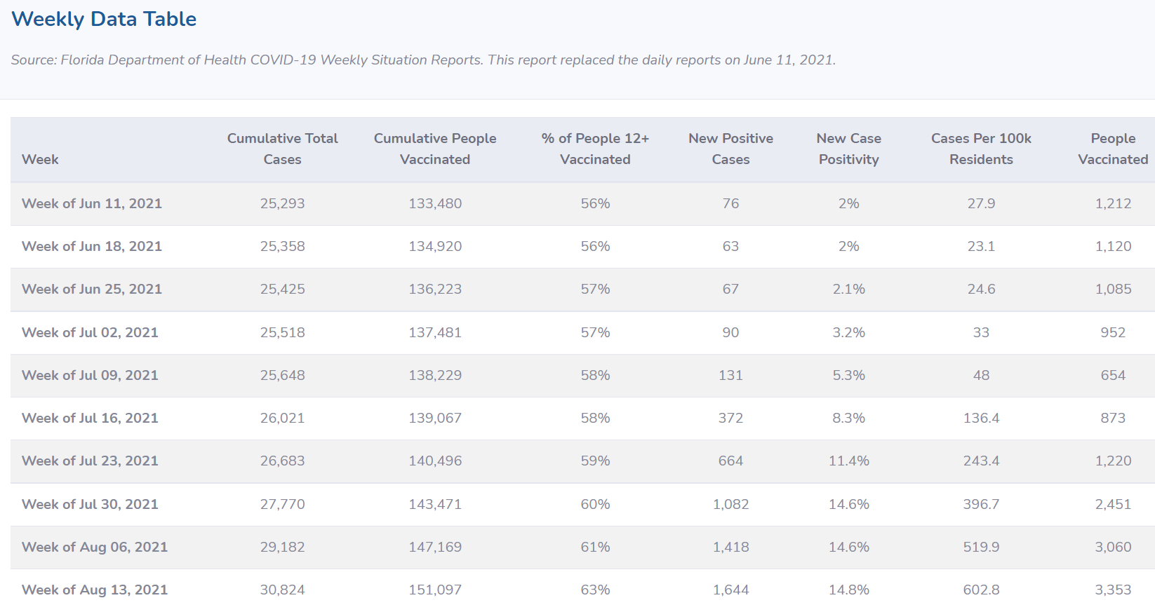
Current Data
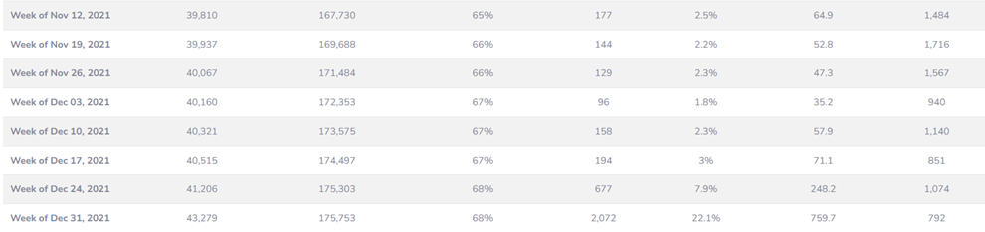

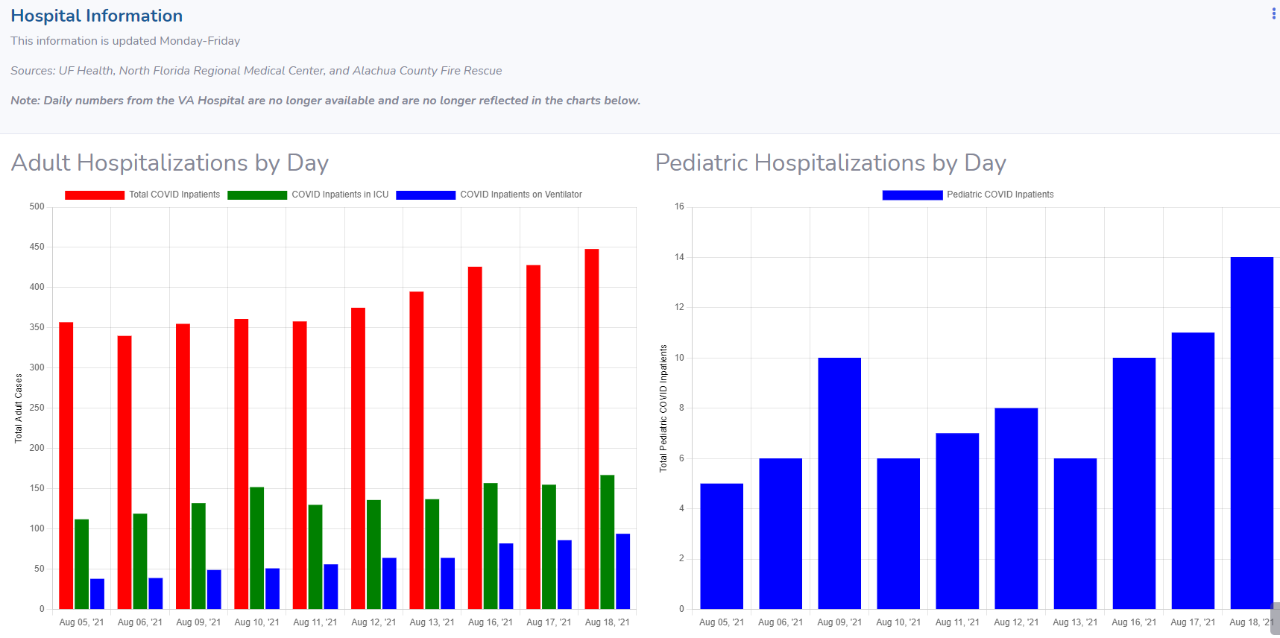

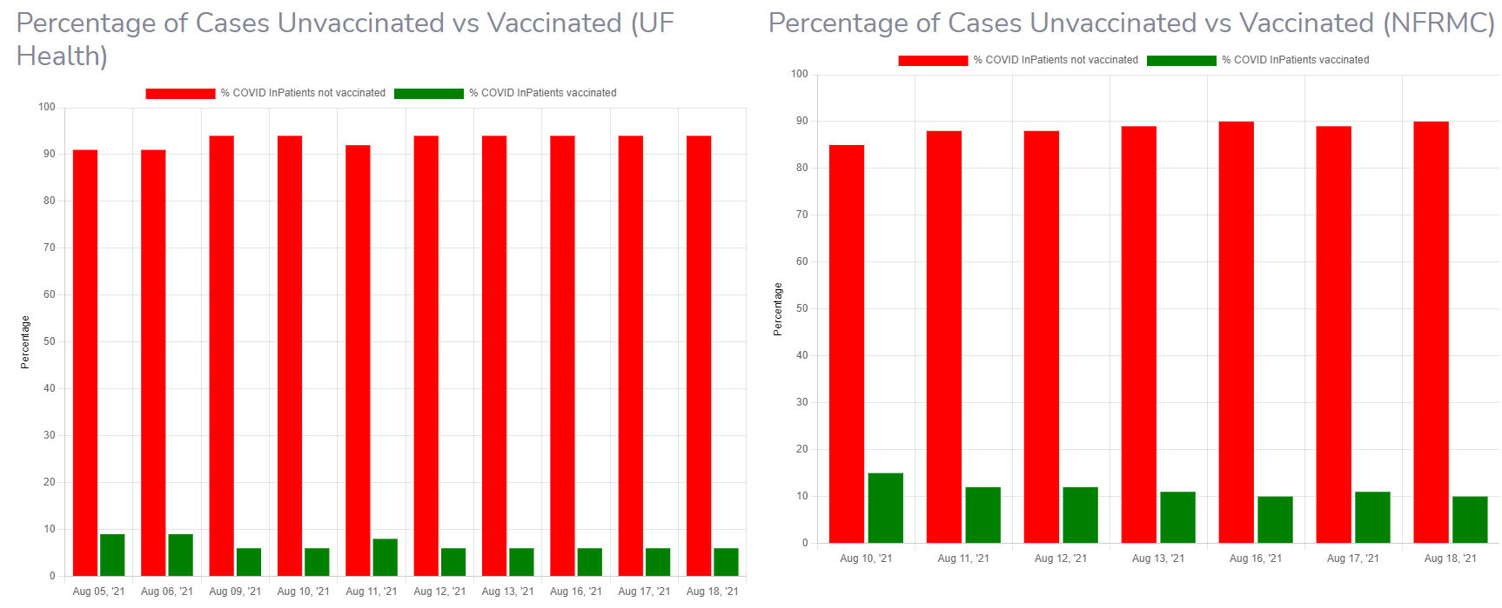

Uses of Funds
The Alachua County Government Employee Vaccination Program aligns with the Public Health, COVID-19 Vaccination category (1.1) under the American Rescue Plan – State and Local Fiscal Recovery Funds. Having a fully vaccinated workforce will allow County Government Services to be provided to vulnerable, disproportionally impacted and economically challenged citizens will reduce the spread of COVID-19, reduce the anxiety to those seeking services, and provide a more stable workforce that is not out due to COVID-19 illness.
Under the Alachua County Government Employee Vaccination Program, all employees of the Board of County Commissioners and Constitutional Officers will be provided an incentive award of $500 upon being fully vaccinated. If they are not currently fully vaccinated, they may receive $250 after the first shot and $250 after the second shot, as long as they receive the first shot (or the Johnson & Johnson shot) prior to September 15, 2021. If an employee is not eligible for the vaccination because they recently had COVID-19, there timeline for the first shot may be extended to the date of eligibility as determined by their physician.
County staff will coordinate with the Clerk’s office to ensure all taxes and benefit issues are in compliance with Federal and State laws.
The program maximum cost will be $1,200,000. This would represent a 100% vaccination rate. Achieving the 90% goal will cost $1,080,000.
Restart January 12, 2022 - The original program identified around 1,600 employees as vaccinated at a cost of ~$800,000. We anticipate a similar response with the booster program and estimate it will cost $400,000, mostly for boosters. The program will provide $100 to each employee for a COVID booster shot from the end of the last program period through February 28, 2022. The program will provide $100 for an employee receiving the 1st and/or 2nd vaccination (up to $200) January 1, 2022 – February 28, 2022. Medical deferrals and time limitations between shots will allow an extension on a case by case basis.
Goals and Measures
The Board of County Commission employees are currently required to self-report their vaccinations status by August 31, 2021. BoCC staff information will be updated through the September 15, 2021 deadline. Constitutional Officers will provide payment to their employees and invoice the County. Upon completion we will report current vaccination rates to the Board.

Our goal is to attain an 90% vaccination rate of employees. We will measure and report progress to the Manager on a weekly basis and provide a final report of effectiveness of the program in late September 2021.

Restart January 12, 2022 – The County employee vaccination rate is 81%. The goal is to attain a 90% employee vaccination rate with all eligible employees receiving their booster shot by February 28, 2022.

June 30, 2022: approximately 1,602 employees received the incentive with approximately 85% of the ABoCC and Constitutional employees vaccinated.

