Alachua County
Recovery Plan

American Rescue Plan

State and Local Fiscal Recovery Funds

County Government Employee Vaccination Program

GENERAL OVERVIEW

Executive Summary
In response to the COVID-19 Pandemic, the Federal government has provided Alachua County funding through the American Rescue Plan – State and Local Fiscal Recovery Funds. One Category of response is Public Health – COVID-19 Vaccinations (1.1). Alachua County is currently considered a “hotspot” of transmission. As of the week of August 13th, the County has reported 30,824 cumulative cases, and is at a 14.8% positive test rate. Vaccination rates in Alachua County are at ~63% which reflects ~151,000 vaccinated citizens out of ~240,000 eligible (12 years old and over) population. (see Weekly Data Table below). The spread of the Delta variant has resulted in increased demand for hospital emergency rooms and admission, including pediatric admissions. Data indicates the vast majority of cases resulting in hospitalization are from people not vaccinated (see Hospital Information table on the next page).

Alachua County Government, including Constitutional Officers, provide necessary and needed services to citizens’ through-out the County. Vulnerable and disproportionate citizens frequently request assistance from Public Safety, Health and Economic needs. It is important that the employees delivering these services are protected to the highest extent possible so that not only are they protected, but they are also limiting the spread to the citizens that we serve. Our goal is to have as many vaccinated employees as possible to prevent the spread of COVID-19.

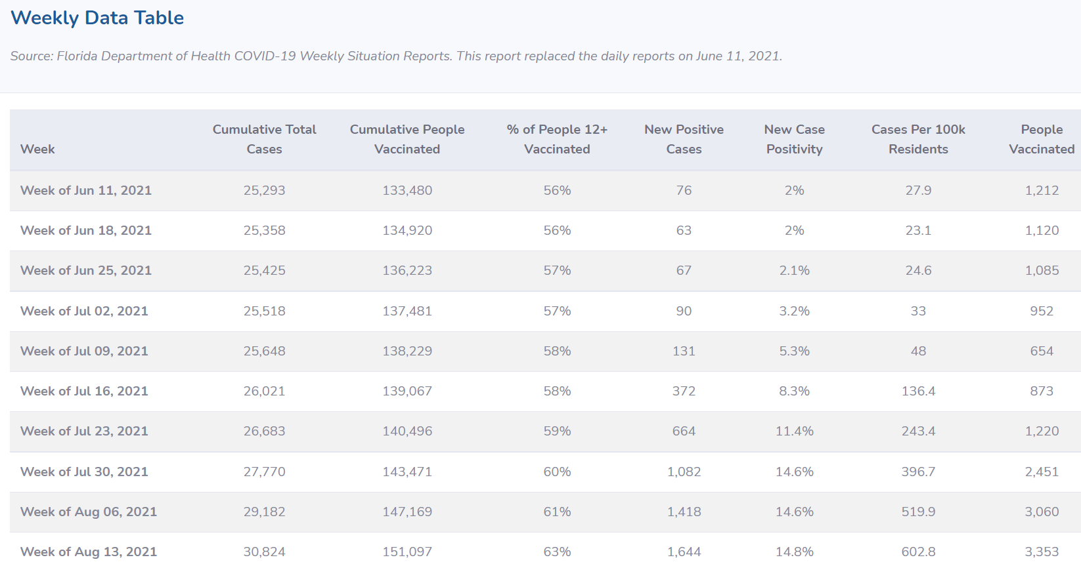

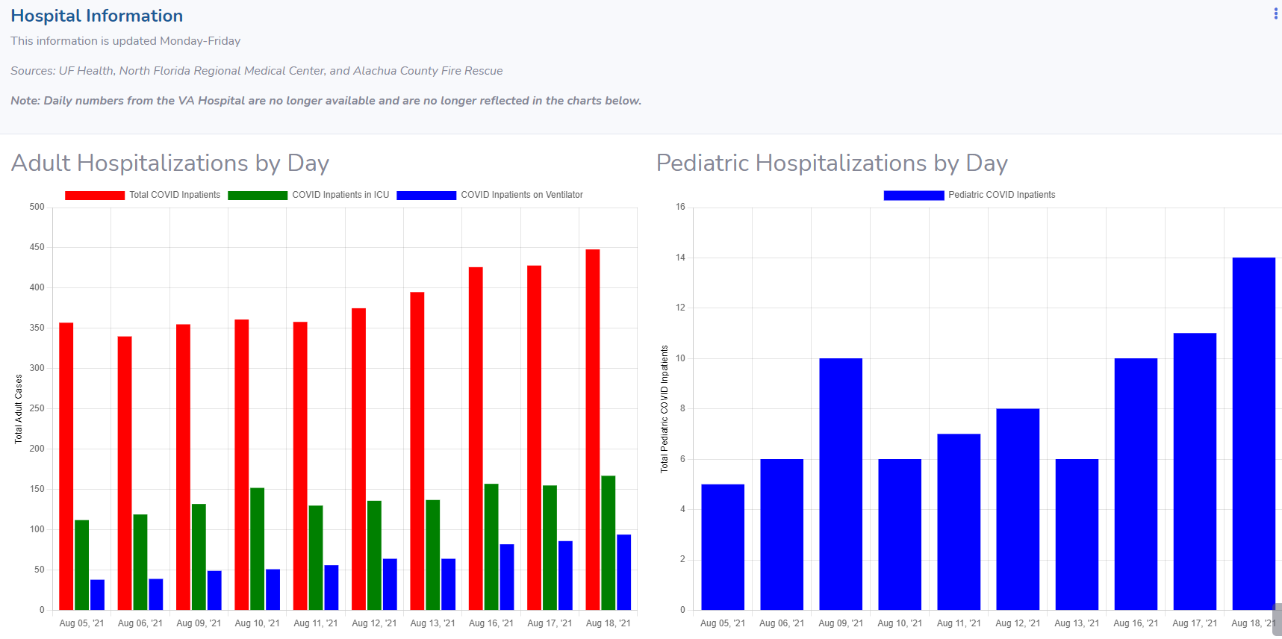

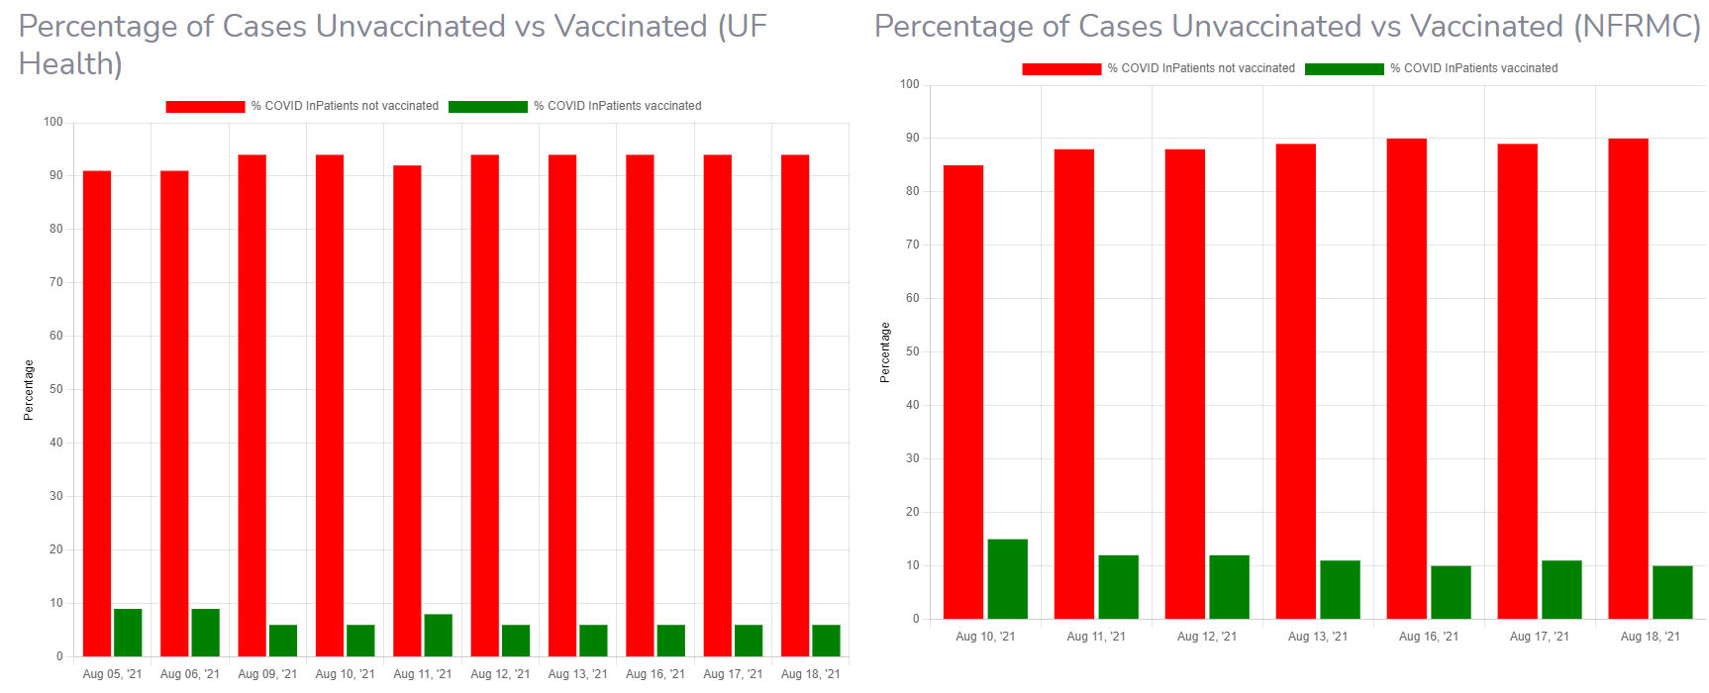

Uses of Funds
The Alachua County Government Employee Vaccination Program aligns with the Public Health, COVID-19 Vaccination category (1.1) under the American Rescue Plan – State and Local Fiscal Recovery Funds. Having a fully vaccinated workforce will allow County Government Services to be provided to vulnerable, disproportionally impacted and economically challenged citizens will reduce the spread of COVID-19, reduce the anxiety to those seeking services, and provide a more stable workforce that is not out due to COVID-19 illness.

Under the Alachua County Government Employee Vaccination Program, all employees of the Board of County Commissioners and Constitutional Officers will be provided an incentive award of $500 upon being fully vaccinated. If they are not currently fully vaccinated, they may receive $250 after the first shot and $250 after the second shot, as long as they receive the first shot (or the Johnson & Johnson shot) prior to September 15, 2021. If an employee is not eligible for the vaccination because they recently had COVID-19, there timeline for the first shot may be extended to the date of eligibility as determined by their physician.

County staff will coordinate with the Clerk’s office to ensure all taxes and benefit issues are in compliance with Federal and State laws.

The program maximum cost will be $1,200,000. This would represent a 100% vaccination rate. Achieving the 90% goal will cost $1,080,000.

Goals and Measures
The Board of County Commission employees are currently required to self-report their vaccinations status by August 31, 2021. BoCC staff information will be updated through the September 15, 2021 deadline. Constitutional Officers will provide payment to their employees and invoice the County. Upon completion we will report current vaccination rates to the Board.

Our goal is to attain an 90% vaccination rate of employees. We will measure and report progress to the Manager on a weekly basis and provide a final report of effectiveness of the program in late September 2021.

