Alachua County Florida
Recovery Plan

American Rescue Plan

State and Local Fiscal Recovery Funds

Alachua County Broadband –
County-wide Residential
ARP2021x005

Executive Summary
In response to the COVID-19 Pandemic, the Federal government has provided Alachua County funding through the American Rescue Plan – State and Local Fiscal Recovery Funds. One Category of response is Broadband Infrastructure (5.16 and 5.17). During the pandemic it became apparent that the need for the ability Telemedicine, Telework and home based education opportunities was inequitable in access and affordability. Based on information from the FCC Fixed Broadband Deployment site ( https://broadbandmap.fcc.gov/ ) as of June2020, excluding satellite ISP, over 49% of the 63,612 rural residential units have less than 100/10 mbps speed. (See map below)

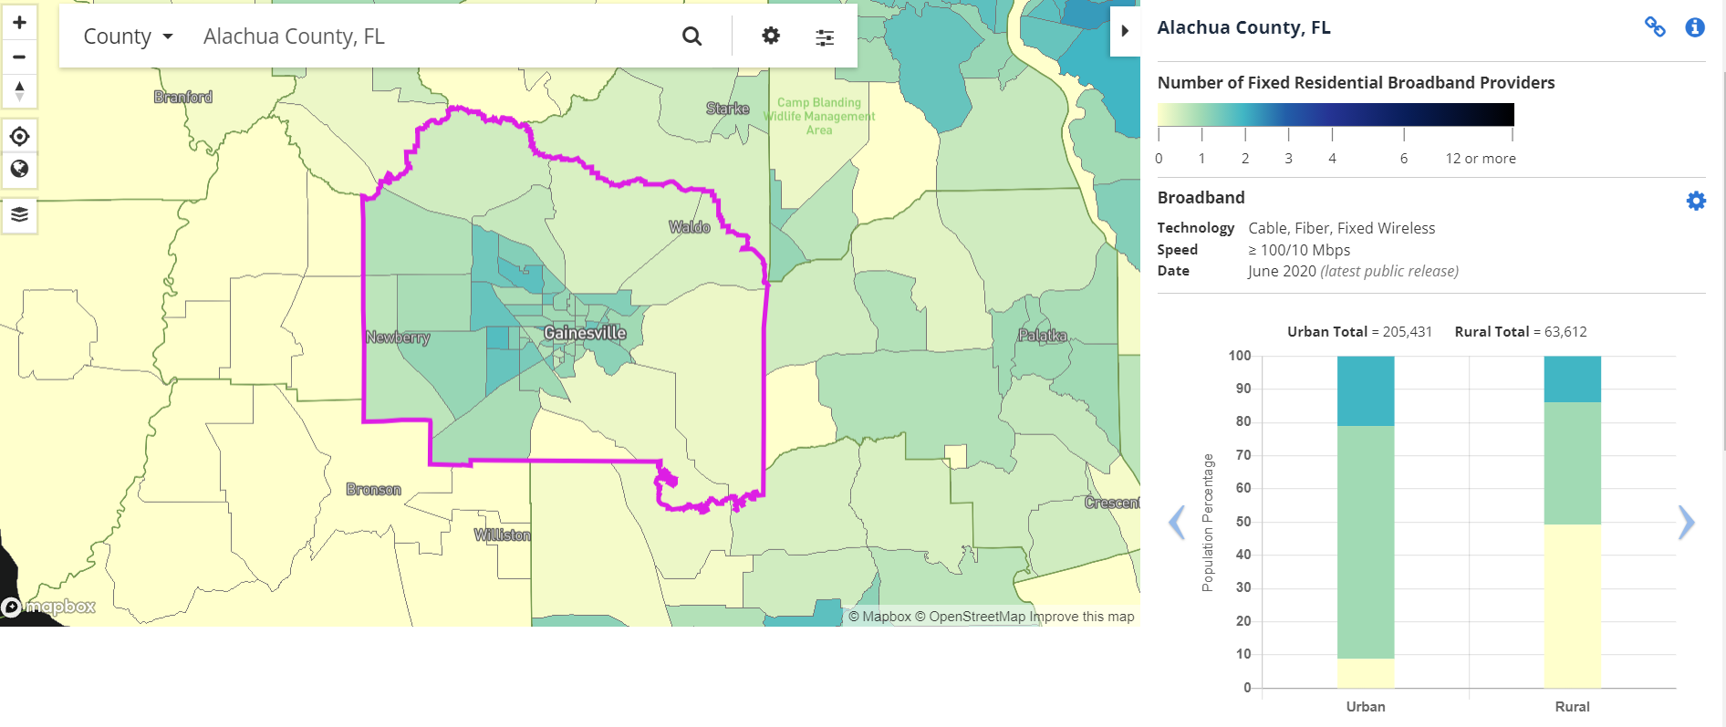

Uses of Funds
The ABoCC allocation to create equity in Broadband access and affordability for unserved and underserved population is $15 Million. In addition to these funds, the County will collaborate with local cities, school board, colleges and UF to understand the entirety of the impact on unserved and underserved communities. The County intends to also leverage these dollars with ISP to acquire match funding, as well as possible FCC and USDA grants.

Promoting equitable outcomes
The final project approval will include:
- Speeds/pricing tiers to be offered, including the speed/pricing of its affordability offering
- Technology to be deployed
- Miles of fiber
- Cost per mile
- Cost per passing
- Number of households projected to have increased access to broadband meeting the minimum speed standards in areas that previously lacked access to service of at least 25 Mbps download and 3 Mbps upload
  - Number of households with access to minimum speed standard of reliable 100 Mbps symmetrical upload and download
  - Number of households with access to minimum speed standard of reliable 100 Mbps download and 20 Mbps upload
- Number of institutions and businesses projected to have increased access to broadband meeting the minimum speed standards in areas that previously lacked access to service of at least 25 Mbps download and 3 Mbps upload, in each of the following categories: business, small business, elementary school, secondary school, higher education institution, library, healthcare facility, and public safety organization
  - Specify the number of each type of institution with access to the minimum speed standard of reliable 100 Mbps symmetrical upload and download; and
  - Specify the number of each type of institution with access to the minimum speed standard of reliable 100 Mbps download and 20 Mbps upload

Labor Practices
The final project plan for Broadband infrastructure will address labor practices in their plans during ABoCC adoption. It will include, when possible, how the project is using strong labor standards to promote effective and efficient delivery of high-quality infrastructure while also supporting the economic recovery through strong employment opportunities for workers. For example: project labor agreements, community benefits agreements, prevailing wage requirements, and local hiring.

Performance Report: Goals and Measures
The goal is for every resident of Alachua County to have access to affordable broadband internet.
June 30, 2022: Surveys are underway to identify unserved and underserved populations. The Regional Technology Planning Team has been created and are tasked with developing a plan in compliance with Florida Department of Economic Opportunities, Office of Broadband, requirements to access Federal and State funding for broadband expansion. A feasibility study and build-out plan is under development. The final project plan will go to the ABoCC in the fall of 2022.

