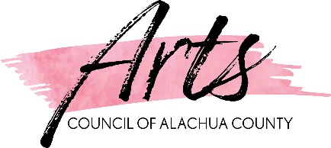
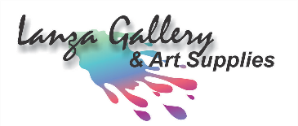
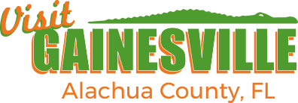

FIRST ANNUAL ARTISTS CONFERENCE
SCHEDULE
“Where Nature and Cultural Meet”
Friday, May 6, 2022
8:30 am – 5:00 pm
Kanapaha Botanical Gardens

Registration & Continental Breakfast  Sponsored by Linda Blondheim  Registration Open, Networking, and Continental Breakfast | 8:00 am – 8:30 am
Welcome  Commission Chair, Marihelen Wheeler  David Ruiz, Arts Council Chair | 8:30 am – 8:40 am
Poetry Reading  E. Stanley Richardson, Poet Laureate | 8:40 am – 8:50 am
State Legislative Update  Gina Peebles, Alachua County | 8:50 am – 9:20 am
Demystifying the Destination Enhancement Grants Process  Jessica Hurov – Visit Gainesville, Alachua County, FL | 9:20 am – 10:20 am
Beverage Break  Sponsored by Gainesville Fine Arts Association (GFAA) | 10:20 am – 10:35 am
Grant Writing Tips and Tricks for Alachua County’s Mini Grant Program  Gina Peebles – Alachua County and Dr. Queenchiku Ngozi – Arts Council  Participants will learn tips and tricks to submit a competitive grant application funded by Alachua County’s art tag proceeds. | 10:35 am – 11:35 am
Lunch  Sponsored by Visit Gainesville, Alachua County, FL | 11:40 am – 12:30 pm
Understanding the County’s Call to Artists Process  Leira Cruz Caliz – Alachua County Procurement  This session is to ask, question, and understand the County’s Call to Artists process. | 12:30 pm – 1:30 pm
The Cycle: Management of Successful Arts and Cultural Organizations  Moderated by Paul Gabbard, Y-Not Theatre  Developed by Michael Kaiser this approach to creating art is for any discipline, any size, and all organizations struggling with today's financial issues. In this workshop, we will walk through the cycle and learn from Mr. Kaiser's own experiences at the Kennedy Center, Alvin Alley Dance Theatre, American Ballet Theatre, and The Royal Opera House. We will also discuss how this model can be applied to our community of Alachua County. | 1:30 pm – 2:30 pm
Break  Sponsored by Tina Corbett - Lanza Gallery & Art Supplies | 2:30 pm – 2:45 pm
How Social Media Can Work for You!  Sean Plemons - Visit Gainesville, Alachua County, FL  This session will help you better understand various social media platforms to engage with your audience. | 2:45 pm – 3:45 pm
Artist-Centered Design  Iryna Kanishcheva – Arts Council  This interactive session will address challenges and opportunities of public art. Artists will be engaged in the discussion, providing feedback, receiving advice on how to be competitive, and how the Arts Council can support them. | 3:45 pm – 4:45 pm
Closing Remarks | 4:45 pm – 5 pm

FIRST ANNUAL ARTISTS CONFERENCE
SCHEDULE
“Where Nature and Cultural Meet”
Friday, May 6, 2022
8:30 am – 5:00 pm
Kanapaha Botanical Gardens

I will attend in-person ____ OR virtually ____ (please check one)

Name:

Agency/Title:

Address:

City/State/Zip:

Daytime Telephone: ( )

Email:

